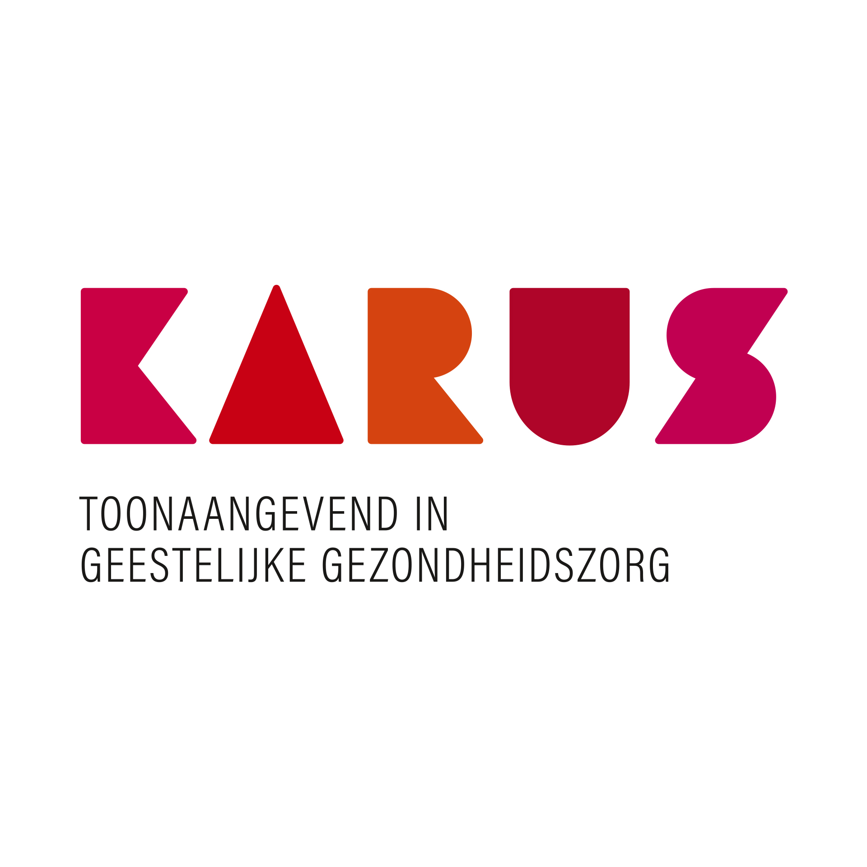

department brochure

PRISMA

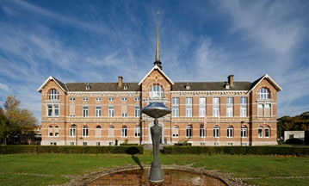

V.U. Katlyn Colman

Maatschappelijk zetel

Caritasstraat 76 – 9090 Merelbeke-Melle

BTW BE 0861.314.369 – RPR Gent

[info@karus.be](mailto:info@karus.be) – www.karus.be

09 210 69 69

Welcome to Prisma!

You are admitted to department “Prisma” for treatment and we would like to make your stay as comfortable and as beneficial as possible. This brochure provides you with information about our manner of working, in addition to the general brochure of Karus.

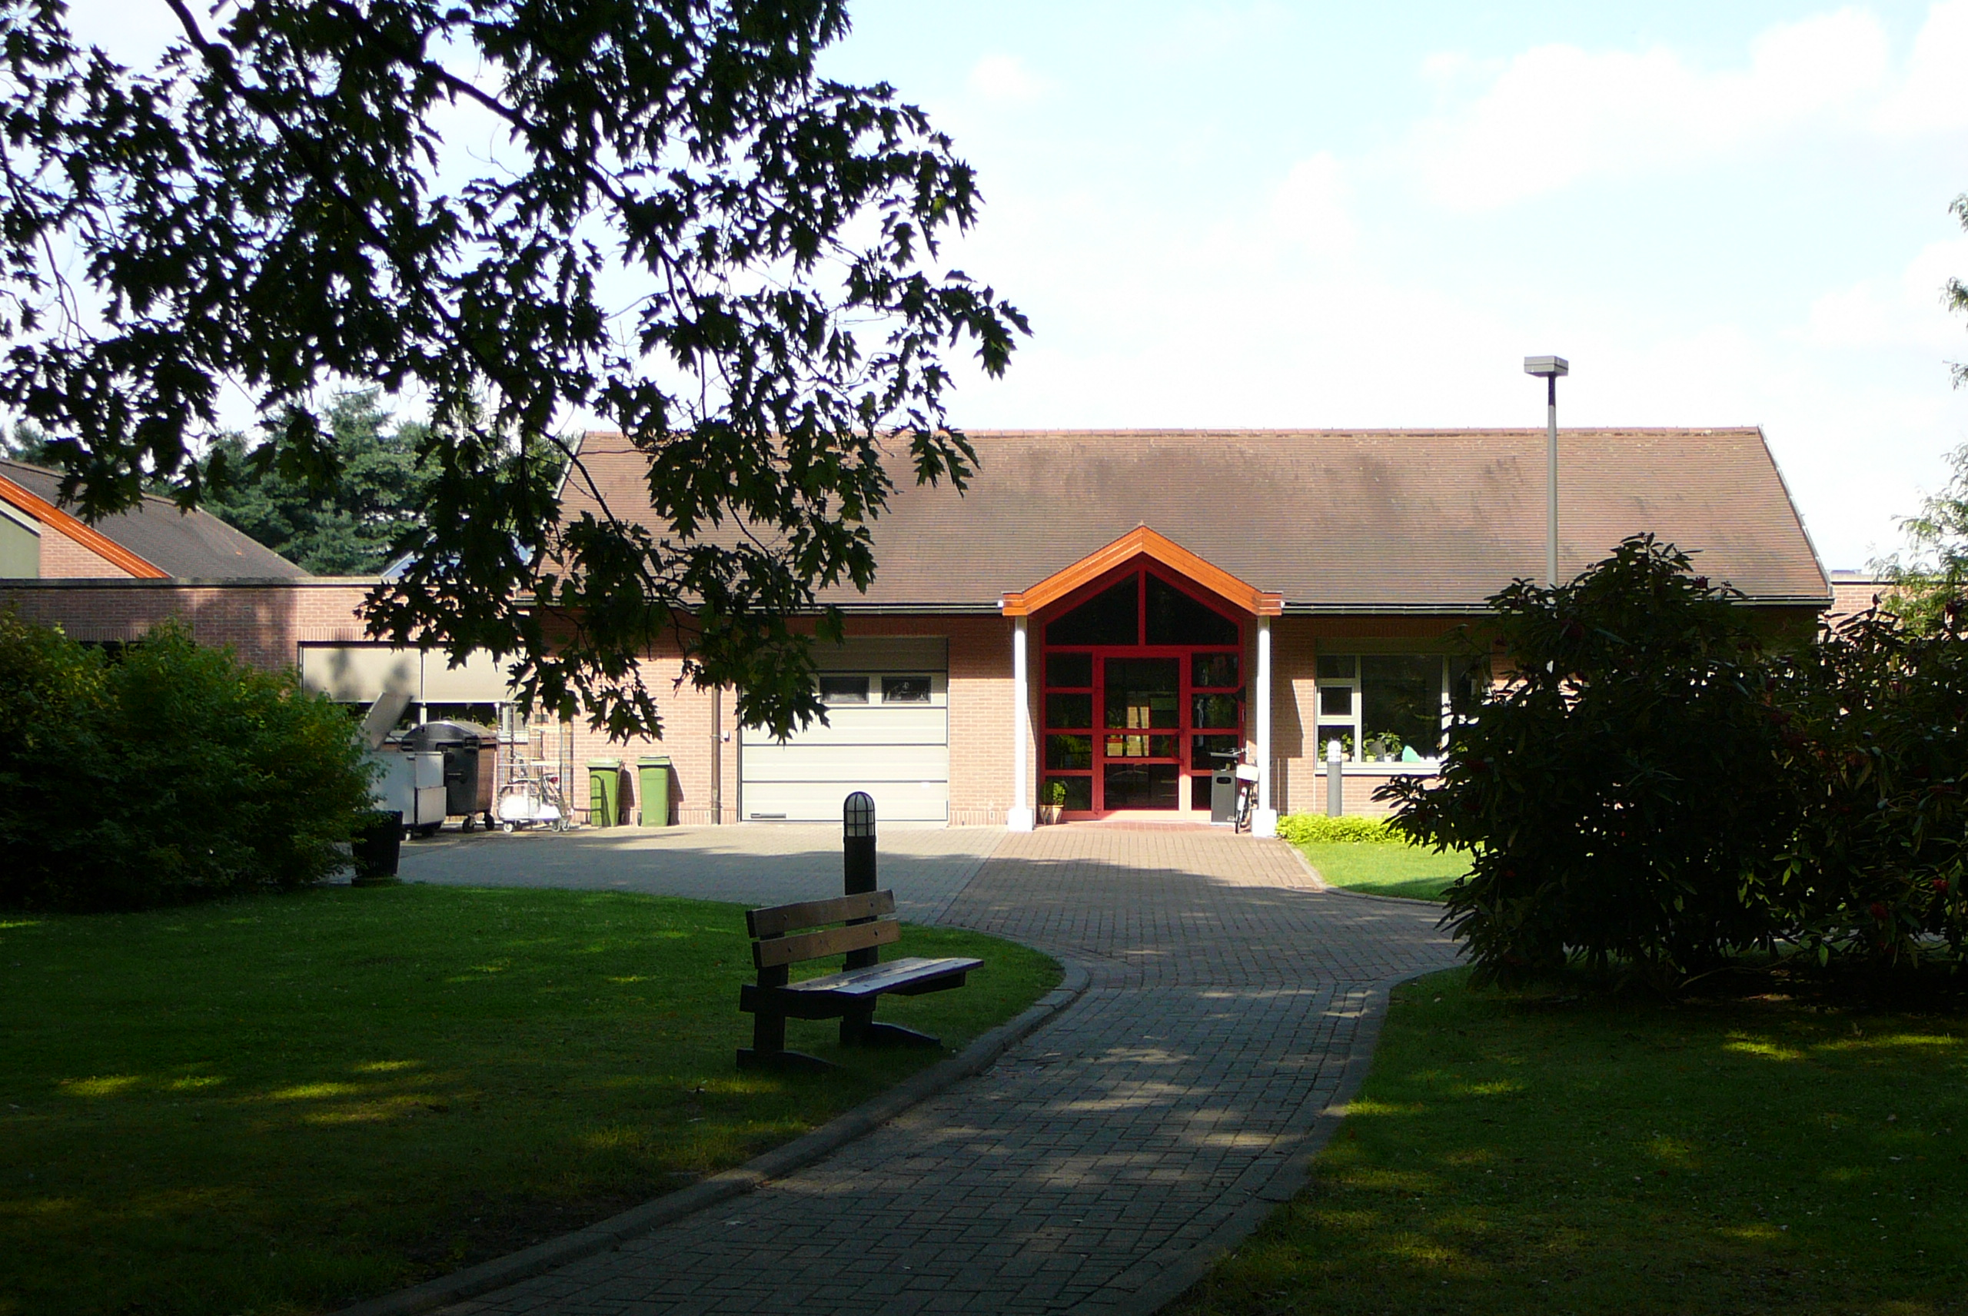

Where did you arrive?

Prisma is an open treatment ward with 30 beds. You will sleep in a single room or a double room. Our ward has different living rooms, a therapy room and a garden. To activate you, we organise several therapies outside of the ward.

Patients can come to us for an admission, as well as for day treatment or for medication only. We will decide together with you which form of support suits you best.

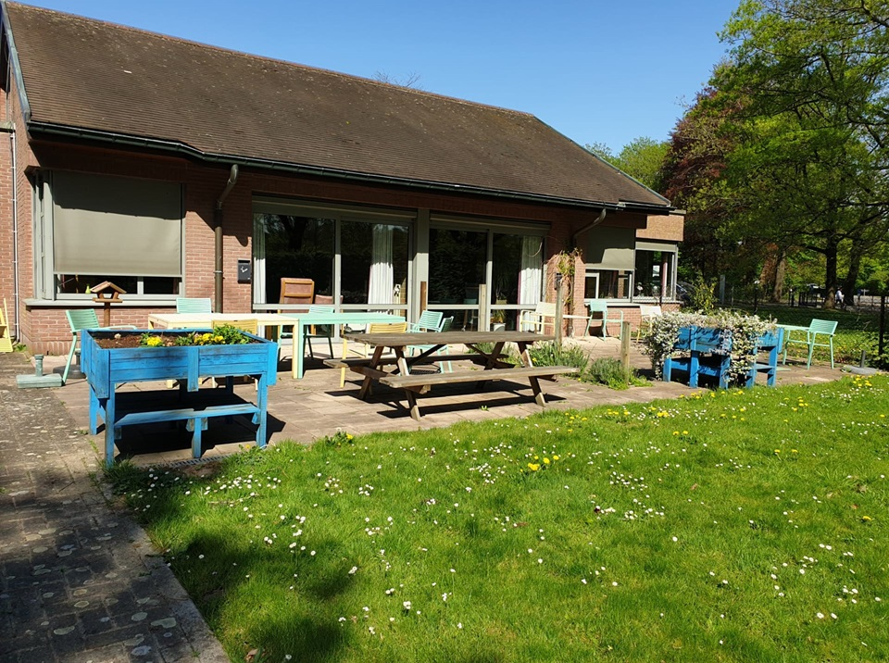

What will happen during your stay/day treatment?

Process of treatment

At the start, we will focus on offering you safety, on bringing structure to your day and on activating you as much as possible. We’ll stay in touch with your everyday life by letting you practise in your home environment on Wednesday afternoons and weekends.

We will gradually build towards more therapies, tailored to your needs as much as possible. Our team members will also join you outside of the hospital. The better you succeed in taking back your place in society, the more we can work towards your discharge.

Therapy program

The patients are assigned to different therapy groups. We find it important that the groups are not too big and that you can connect with the others in your group.

Group 1: The focus is on stabilisation. In a safe and supportive structure, you will take back control of yourself and reality.

Group 2: The therapy program becomes more intense and more tailored to your possibilities and personal goals. We motivate you to take up more independence and to train your skills outside of the hospital.

Group 3: The focus shifts towards rehabilitation. You gradually take more control over your daily activities and continue to build on your life after discharge. The team members are mainly present in a supportive manner.

We think it is important that you have a say in your therapy program. In addition to the standard program per group, we also offer therapies you can choose. In consultation with you, it is decided which additional therapies you want to join.

Our team pays extra attention to a healthy lifestyle. We support you in your daily hygiene, your sleeping pattern and healthy nutrition. We also encourage you to exercise enough and offer weekly information sessions on all these topics.

Life outside of therapy sessions

During your stay you can – in consultation with the team and your housemates – enjoy free time. On Wednesdays, the afternoon is free from 2pm till 8pm.

On Weekends, you can take a free day from 8am till 8pm. Long weekends can range from Friday 5pm till Sunday 11.30am, or from Saturday 2pm till Sunday 8pm.

You can receive visitors on weekdays between 6pm and 8pm. On Wednesday-, Saturday- and Sunday afternoon you can receive visitors between 1.30pm and 8pm.

We ask you to receive your visitors in your room or on the domain, but not in the common areas. This to safeguard the rest and privacy of other patients as much as possible.

Working with your context

On admission, we ask about significant others. Depending on your request, your parents, your partner, your kids or other people from your network can be invited to the psychologist, the social worker or your individual counsellor.

We believe it is important to work together with the people who play an important role in your daily life. With your approval, we also contact the Mobile Team, Sheltered Living, your therapist or others who play a part in your personal story.

After discharge

After discharge, you can return to daily life in steps through day therapy. During your stay, we will look into which care you might need in your home to help prevent a new intake.

Who will look after you?

Structure of the team

On arrival a nurse will welcome you and will give you a tour. He or she will give you information about the structure and the habits of our ward.

You will regularly have an appointment with Dr. De Coninck, responsible psychiatrist of this department. She will evaluate your treatment and your medication.

A psychologist will be assigned to you, Yasmine De Meyer, Heidi Desloovere or Alexandra Vanderbeke. They will give you an appointment and listen to your personal story.

For social, financial or legal issues you can consult a social worker. Jolien Van Speybroeck or Dieter De Muyter will invite you for an introduction.

For complaints or problems, you can always consult Katrien Callens, the department manager. She watches over the organisation of the ward and is always ready to listen.

Our logistic managers, Sylvia and Veronique, will actively involve you in the household tasks of the ward. Together we make Prisma a pleasant place to stay. We also expect your cooperation to keep the rooms tidy and orderly, so the cleaning ladies can work comfortably.

Consultation with the team

We regularly meet with the team to talk about your trajectory. The team meeting is on Tuesdays from 1.30pm till 3.30pm. Your progress will be evaluated about every four weeks. We are happy to hear your own input. Collaboration with the context.

We think it is important to work together with the people who play an important role in the daily life of the patient. At the start, we therefore inquire about the important relatives in his or her environment. We need their permission to speak with parents, partners, children or other persons in the network.

If they give their permission, we will invite you with one of our colleagues, depending on the focus of the conversation. We strive for a warm collaboration where everyone can feel heard. The doctors, psychologists, social workers and department manager can easily be reached by telephone during office hours. For urgent matters, you can also call the department itself, where you will be assisted by the nursing staff.

In addition to individual contacts, we also organize “multilogem” several times a year. In such conversation, several patients, relatives and caregivers discuss topics related to a hospital admission in a friendly atmosphere.

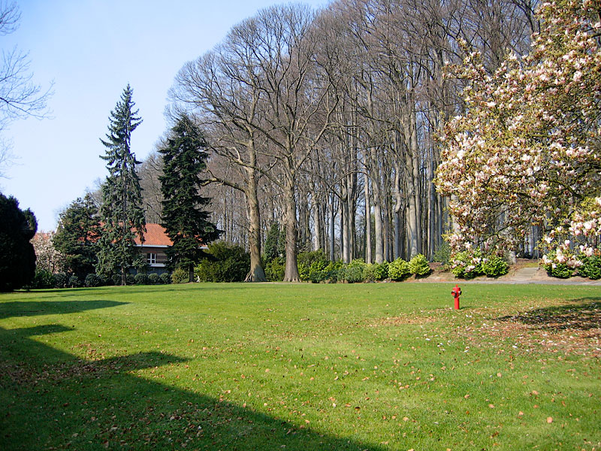

|  |  |  |
| --- | --- | --- |
| Katrien Callens | 09/210 68 20 | katrien.callens@karus.be |
| Yasmine De Meyer | 09/210 65 63 | yasmine.de.meyer@karus.be |
| Heidi De Sloovere | 09/210 65 18 | [heidi.desloovere@karus.be](mailto:heidi.desloovere@karus.be) |
| Alexandra Vanderbeke | 09/210 65 18 | alexandra.vanderbeke@karus.be |
| Jolien Van Speybroeck | 09/210 69 34 | jolien.van.speybroeck@karus.be |
| Dieter De Muyter | 09/241 53 62 | dieter.de.muyter@karus.be |
| Artsen | 09/210 69 69 | shana.de.coninck@karus.be |
| Verpleging | 09/210 65 98 | prisma@karus.be |

Importance of a positive environment 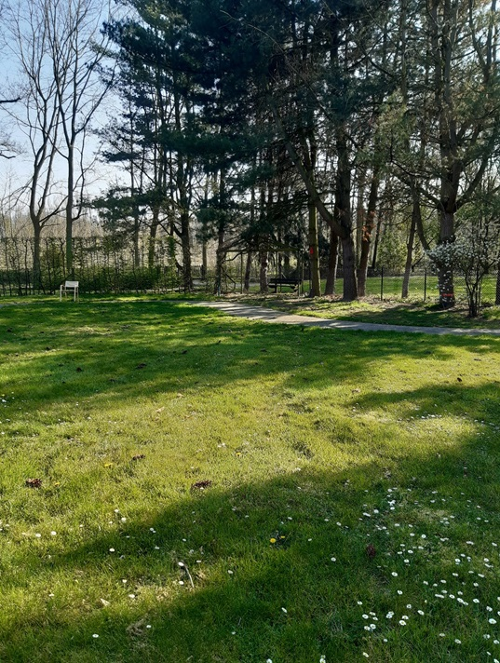

General rules

You can find the general hospital rules in the Karus brochure.

Specific rules

Prisma wants to be a warm and safe environment for all its patients. Therefore we ask to interact with others in a respectful manner. Drugs and alcohol are forbidden. Non-alcoholic alternatives and energy drinks also have no place in our ward. We expect this to be observed during activities outside the ward.

We also value privacy. Patients do not enter each other’s rooms, but meet in the common areas or the garden.

It is not always easy to live with a group of different individuals. Problems can always be brought to the attention of the nursing staff or other team members. Together we can find a solution.

Practical information

General information

You can find the general practical information in the Karus brochure.

Specific information

Every room is equipped with a mini fridge. This can only be used to cool drinks. We ask that you bring as little food as possible to the ward. If you do bring food with you, it is stored in a separate fridge in the kitchen.

The ward is equipped with a washing machine and a dryer. These can be used by patients who do not yet leave the ward. Using this is not free. Anyone who has already been allowed to exit is expected to do their laundry at home or in a laundrette.

Legal information

We would like to point out the regulations regarding driving skills. We therefore advise against driving vehicles during your stay. Your admission means that you are in a crisis moment and that your medication can be changed. These are matters that are stated in the regulations.

Do you have questions or comments?

For questions or comments, you can always reach the ward at 09/210 65 98 or via prisma@karus.be

NOTITIES

……………………………………………………………………………………………………………………………………………………………………………………………………………………………………………………………………………………………………………………………………………………………………………………………………………………………………………………………………………………………………………………………………………………………………………………………………………………………………………………………………………………………………………………………………………………………………………………………………………………………………………………………………………………………………………………………………………………………………………………………………………………………………………………………………………………………………………………………………………………………………………………………………………………………………………………………………………………………………………………………………………………………………………………………………………………………………………………………………………………………………………………………………………………………………………………………………………………………………………………………………………………………………………………………………………………………………………………………………………………………………………………………………………………………………………………………………………………………………………

…………………………………………………………………………………………………………………………………………………………………………………………………………………………………………………………………………………………………………………………………………………………………………………………………………………………………………………………………………………………………………………………………………………………………………………………………………………………………………………………………………………………………………………………………………………………………………………………………………………………………………………………………………………………………………………………………………………………………………………………………………………………………………………………………………………………………………………………………………………………………………………………………………………………………………………………………………………………………………………………………………………………………………………………………………………………………………………………………………………………………………………………………………………………………………………………………………………………………………………………………………………………………………………………………………………………………………………………………………………………………………………………………………………………………………………………………………………………………………………………………………………………………………………………………………………………………………………………………………………

…………………………………………………………………………………………………………………………………………………………………………………………………………………………………………………………………………………………………………………………………………………………………………………………………………………………………………………………………………………………………………………………………………………………………………………………………………………………………………………………………………………………………………………………………………………………………………………………………………………………………………………………………………………………………………………………………………………………………………………………………………………………………………………………………………………………………………………………………………………………………………………………………………………………………………………………………………………………………………………………………………………………………………………………………………………………………………………………………………………………………………………………………………………………………………………………………………………………………………………………………………………………………………………………………………………………………………………………………………………………………………………………………………………………………………………………………………………………………………………………………………………………………………………………………………………………………………………………………………………



V.U. Katlyn Colman

Maatschappelijk zetel

Caritasstraat 76 – 9090 Merelbeke-Melle

BTW BE 0861.314.369 – RPR Gent

[info@karus.be](mailto:info@karus.be) – www.karus.be

09 210 69 69